STUDENT PERFORMANCE ANALYSIS DASHBOARD REPORT

# DAX FUNCTIONS

Data Analysis Expressions (DAX) is a programming language that is used throughout Microsoft Power BI for creating calculated columns, measures, and custom tables. It is a collection of functions, operators, and constants that can be used in a formula, or expression, to calculate and return one or more values. DAX language is very useful as it allows Data Analysts to perform advanced calculations and discover a hidden pattern in an unstructured dataset. The complete code of an expression is always a function or nested function with conditional statements, value references, formulas, loops, etc.

**Syntax** – Proper DAX syntax is made up of a variety of elements, some of which are common to all formulas. When trying to understand a DAX formula, it is often helpful to break down each of the elements into a language you think and speak every day. So, this formula includes the following syntax elements:

1. SUM:

Sumofmarks = SUM(‘studentperformacefactors’[marks_score])

1. AVERAGE (single factor):

Avg_marks = AVERAGE(‘studentperformacefactors’[marks_score])

1. AVERAGE (multiple factors):

AverageMarksFemales =

CALCULATE(

AVERAGE('StudentPerformance'[Score]),

'StudentPerformance'[Gender] = "Female"

)

1. AVERAGE SCORES OF FEMALES AND MALES

AverageScoreFemales =

    CALCULATE(

        AVERAGE('StudentPerformanceFactors (3)'[Exam_Score]),

        'StudentPerformanceFactors (3)'[Gender] = "Female"

    )

AverageScoreFemales =

    CALCULATE(

        AVERAGE('StudentPerformanceFactors (3)'[Exam_Score]),

        'StudentPerformanceFactors (3)'[Gender] = "Male"

    )

1. TOTAL FEMALES AND MALES:

Femalesmarks =

    CALCULATE(

        AVERAGE('StudentPerformanceFactors (3)'[Exam_Score]),

        'StudentPerformanceFactors (3)'[Gender] = "Female"

malesmarks =     CALCULATE(

        AVERAGE('StudentPerformanceFactors (3)'[Exam_Score]),

        'StudentPerformanceFactors (3)'[Gender] = "male"

  )

1. TOTAL NUMBER OF CLASSES

Total_classes = TOTAL(studentperformacefactors’[sessions])

1. **Demographics and Exam Scores**

**Chart Type:** Stacked Bar Chart

**Description:** This chart illustrates the average Exam Scores segmented by various demographic factors, including Gender and Family Income.

**X-Axis:** Gender or Family Income

**Y-Axis:** Average Exam Score

STUDENT PERFORMACE DASHBOARD

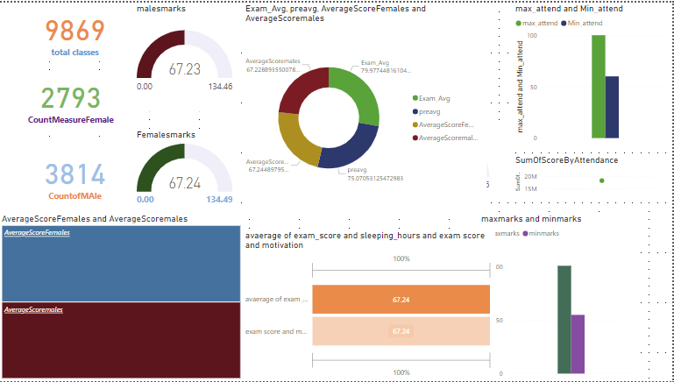

CONCLUSION:

The Student Performance Dashboard offers essential insights into the influence of various factors—such as study habits, attendance, motivation, and parental involvement—on student exam scores. Leveraging DAX calculations, the dashboard effectively uncovers patterns and relationships within the data, empowering educators and administrators to pinpoint critical areas for intervention. This tool serves as a valuable resource for comprehending the dynamics of academic success and facilitating data-driven decisions aimed at enhancing student outcomes.